More than 35 years after the ADA, autistic adults still struggle | Opinion
Christopher J. Manente and SungWoo Kahng
DOI: 10.1016/j.ridd.2017.04.004, Show Details

Published: Mar. 29, 2026, 11:59 a.m.
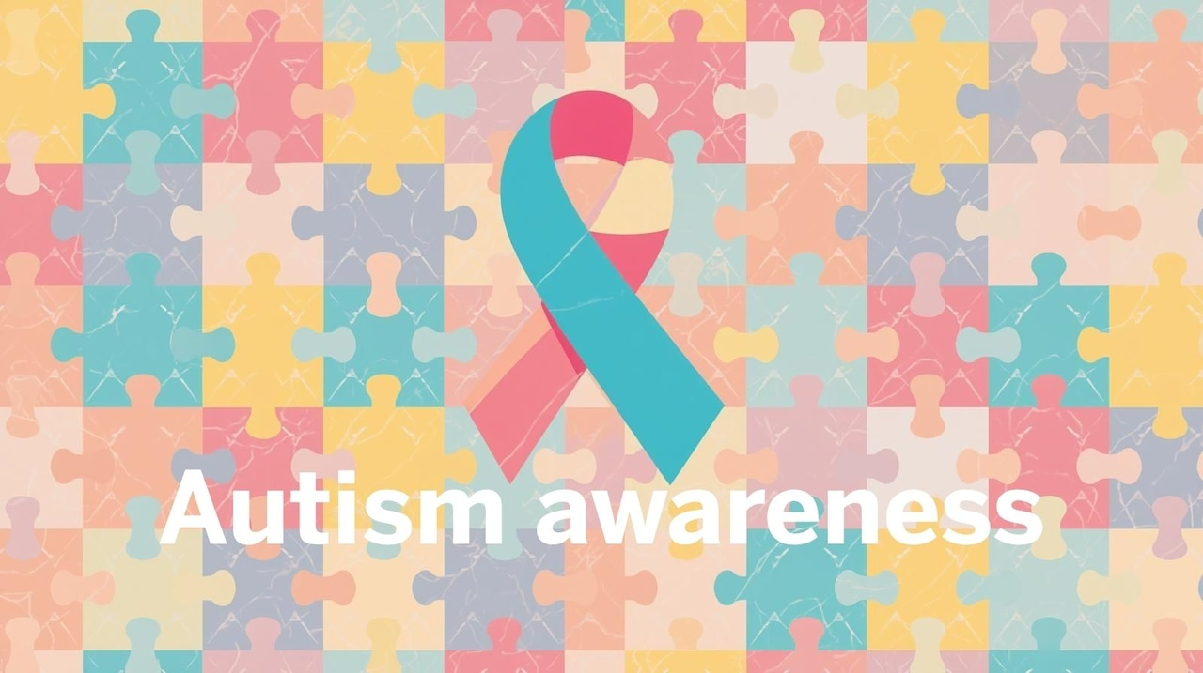
About 1 in 29 children in New Jersey are identified with autism. (Canva.com)
By Christopher J. Manente and SungWoo Kahng, Rutgers Center for Adult Autism Services
When the Americans with Disabilities Act (ADA) was signed into law on July 26, 1990, President George H.W. Bush declared, “Every man, woman and child with a disability can now pass through once-closed doors into a bright new era of equality, independence and freedom.”
He described the ADA as a sledgehammer that would destroy a generational wall of discrimination that had “separated Americans with disabilities from the freedom they could glimpse but not grasp,” and proclaimed, “Let the shameful wall of exclusion finally come tumbling down!”
More than 35 years later, the ADA has improved the lives of many people with visible disabilities. Curb cuts, ramps, accessible bathrooms and parking spaces, closed captioning and other environmental improvements — accommodations that are simple in their design and implementation, and universally effective — have reshaped the physical landscape of American life.
Who the ADA left behind
Yet in New Jersey and across the country, the more than 5.5 million adults with autism living in the United States collectively continue to have the poorest quality of life throughout their lifespan compared with any other demographic group in America, a disparity that is especially important to recognize as April marks National Autism Acceptance Month. For autistic adults, the wall of exclusion remains and is arguably as tall as ever. How and why have autistic people been left behind?
A “curb cut” is a ramp incorporated into a sidewalk that allows someone using a wheelchair to transition from the street. Despite their simplicity, they are universally effective in meeting the needs of wheelchair users. The consistency of design and universal effectiveness of curb cuts have led to the widespread incorporation of this accommodation throughout our society.
Why autism accommodations are different
Accommodations required for autistic people to have a chance to succeed in society are rarely so simple.
Autism generally involves some level of difficulty in communicating and connecting with other people, challenges that are often invisible to the observer, versus the very tangible and obvious physical barriers faced by someone using a wheelchair.
Autistic adults are at a great disadvantage in a highly competitive world where people who are regarded as articulate, charismatic, influential and likable have the best chance of succeeding at the highest levels.
The accommodations needed by people with autism can vary drastically from one individual to the next, and there are few examples of accommodations that are universally effective at increasing access for all. The most effective accommodations for autistic adults must be custom built by interdisciplinary professionals with specific expertise to do this work.
Until recently, there hasn’t been an emphasis on examining what happens to children with autism when they become adults. There is no established workforce of highly skilled professionals to provide effective accommodations at scale, there are few existing support programs that autistic adults can turn to for assistance, and there is an absence of university-based training pathways that would address these gaps.
About 75% of autistic adults are unemployed, 87% remain living with their parents, and autistic college students graduate at dramatically lower rates than their peers. The suicide rate among people with autism is nine times that of the general population, and many autistic adults still cannot access even the most basic health care.
A New Jersey blueprint
Here in New Jersey and across the country, U.S. colleges and universities are strategically situated as the epicenter for addressing the underlying factors contributing to the current quality-of-life crisis for autistic adults. These institutions sit at a critical intersection: They train the next generation of professionals, and these future practitioners will be essential to creating the individualized accommodations autistic people need to thrive in diverse settings.
New Jersey has one of the highest prevalence rates of autism in the nation. About 1 in 29 children in the state are identified with autism. At Rutgers University, a renaissance has taken place in the creation of numerous innovative programs and initiatives to ensure access and opportunities for autistic and other neurodivergent people across education, employment, community inclusion, independent living and health care.
The thriving neuro-accessible community we have created is a blueprint for delivering on the promises made by the ADA for autistic people — to “guarantee fair and just access to the fruits of American life which we all must be able to enjoy.”
We remain hopeful that there are legislators and leaders from other universities willing to join us.
Christopher J. Manente is a clinical associate professor at Rutgers Graduate School of Applied and Professional Psychology and executive director of the Rutgers Center for Adult Autism Services
SungWoo Kahng is professor and director of Academic Programs in Autism and Applied Behavior Analysis, Rutgers Graduate School of Applied and Professional Psychology and co-director of Research, Rutgers Center for Adult Autism Services.

